RULES, INFORMATION AND PARKING AGREEMENT
- ALL CARS WILL BE PARKED IN THE CAR LOT (NO EXCEPTIONS) BY ORDER OF THE SPEEDWAY FIRE MARSHAL. ANY UNRESOLVED CONFLICTS WILL RESULT IN REMOVAL FROM THE PARKING LIST.
- IF YOU DESIRE TO ARRIVE EARLY OR PARK YOUR VEHICLES PRIOR TO RACE WEEKEND, ADVANCE NOTICE IS REQUIRED.
- ALL PETS MUCH BE ON A LEASH AND CONTAINED ON YOUR SITE. ALL PET OWNERS MUST CLEAN UP AFTER THEIR PETS.
- CHECKS RETURNED FOR NON-SUFFICIENT FUNDS WILL CANCEL YOUR PARKING AGREEMENT. A $50 NSF FEE WILL APPLY.
- ALL PARKING CREDENTIALS WILL BE AVAILABLE UPON ARRIVAL.
- ALL PARKING PURCHASES/AGREEMENTS ARE NON-REFUNDABLE.
- ALL VISITORS MUST PAY TO PARK WHEN PAID PARKING IS IN EFFECT. NO EXCEPTIONS
- NON-CAMPING VEHICLE PASSES ARE AVAILABLE AND WILL BE ISSUED UPON ARRIVAL AND ARE NON-TRANSFERABLE!
- POST 500 IS NOT RESPONSIBLE FOR SATELLITE RECEPTION. ONCE YOUR SPACE IS ASSIGNED YOU CANNOT MOVE.
- NO FIREWORKS OR OPEN CAMPFIRES ALLOWED. AWNINGS AND CANOPIES CANNOT EXTEND BEYOND YOUR SPACE. NO POLES, STAKES OR ANY OTHER OBJECTS ARE TO BE PLACED ON THE PAVEMENT.
- ALL ELECTRIC SPOTS ARE 30 OR 50 AMP (WHERE AVAILABLE) AND REQUIRE AT LEAST A 50’ CORD. ANYONE CAUGHT TAMPERING WITH THE ELECTRICITY WILL BE REMOVED FROM THE LOT WITHOUT A REFUND.
- WATER IS AVAILABLE FOR STORAGE TANKS ONLY, NO PERMANENT CONNECTIONS AVAILABLE. NO SHOWERS, LAUNDRY,
OR DUMPING FACILITIES ARE AVAILABLE ON SITE. DUMPING SERVICES ARE AVAILABLE, UPON REQUEST FROM A THIRDPARTY VENDOR, FOR A FEE. POST 500 IS NOT RESPONSIBLE FOR THE ACTIONS OF THIRD-PARTY VENDORS. PHONE NUMBERS ARE AVAILABLE IN YOUR PACKET OR IN THE CLUB ROOM.
- NO GENERATOR USAGE IS PERMITTED AFTER 11 PM UNLESS THE EXHAUST IS THROUGH A CHIMNEY. POST 500 RESERVES THE RIGHT TO REQUEST THAT GENERATORS BE TURNED OFF.
AMERICAN LEGION POST 500 IS NOT RESPONSIBLE FOR ACCIDENTS, THEFT, OR LOSS OF PROPERTY, AND RESERVES THE RIGHT TO ORDER ANYONE OFF THE PREMISES WITHOUT A REFUND.
I HAVE READ ALL THE RULES AND THE INFORMATION STATED ABOVE. MY SIGNATURE BELOW INDICATES THAT I, INCLUDING ANY AND ALL GUESTS, WILL ABIDE BY THESE RULES.
____________________________________________ __________________________

SIGNATURE DATE
PAYMENTS BY CREDIT CARD MUST INCLUDE THIS COMPLETED AND A SIGNED APPLICATION FORM.
MAKE CHECKS AND MONEY ORDERS PAYABLE TO SPEEDWAY POST 500. E-MAIL FORM WITH COMPLETE CREDIT CARD INFORMATION TO SpeedwayPost500Parking@gmail.com OR MAIL COMPLETED FORM ALONG WITH PAYMENT TO:
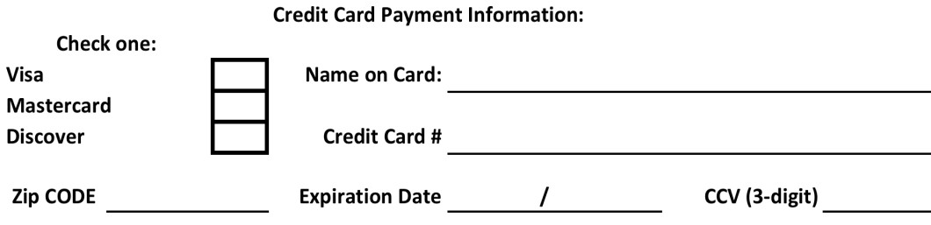
AMERICAN LEGION POST 500

1926
GEORGETOWN RD

SPEEDWAY, INDIANA 46224

PHONE
:

317
-
244
-
9625

wwwSpeedwayLegionPost500.com

Page 2 of 2 Revised 10/17/2020

